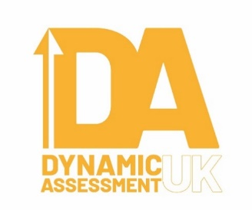

Problem-solving games and resources that can be used when doing Dynamic Assessment

Most of these are made by two companies: Think Fun and Smart Games:

Rush Hour (spatial reasoning and planning are required to manipulate the cars and trucks so that your car can get out of the traffic jam. An app is also available). How To Play: Rush Hour - by ThinkFun

Gravity Maze (the children have to use planning, logic and problem-solving skills to build a maze that will allow the marble to leave the starting point and end up in the finishing point). How To Play: Gravity Maze (2014)
Balance Beans (this is a maths based game for younger primary aged kids). Balance Beans from ThinkFun

Pathwords (this is an excellent one as it is literacy based, using a word search exercise but also combining with problem-solving activity. There are two versions - a basic one and an advanced one): How To Play: Pathwords - by ThinkFun

Hoppers (this is a Solitaire inspired game but for kids) Hoppers, by ThinkFun

Katamino (this is quite a difficult activity where you have to fit some different sized wooden shapes into a confined space: excellent for older and/or more capable kids): How to Play Katamino | Board Game Rules & Instructions

Camelot Junior (this involves problem solving skills, planning and logical thinking: this is a simpler version of Gravity Maze – see above): How to play Camelot Jr. - SmartGames - YouTube

Squirrels Go Nuts (very similar game to Rush Hour, requiring spatial orientation, planning and problem solving skills). How to play Squirrels Go Nuts! - SmartGames

Dobble or Spot it! (this game requires quick thinking and visual perceptual skills): How to Play Dobble or Spot It!: a SPEEDY Search and Match game!

IQ stars (this game is very similar to Katamino but using stars rather than different shapes. Better for older primary and secondary aged children): How to play IQ-Stars - SmartGames

Cat crimes (children have to use deductive reasoning using the clues provided to decide which cat is the culprit): Cat Crimes by ThinkFun

Colour Code (children have to reproduce complex, coloured patterns using various shapes and outlines. This is similar to the Representational Stencil Design sub-test from the Learning Propensity Assessment Device, for those that know it): How to play Colour Code - SmartGames

Tangram (this ancient Chinese puzzle game has been around for centuries. Children have to make up various designs using the various geometrical pieces provided. Visuo-spatial skills and logical reasoning are required). Available in various formats and made by various companies.

Always keep in mind that it's about how the kids tackle the problems and how they respond to the mediation, rather than the content of the tasks themselves, which is why I think it's acceptable to use games/toys that are available on the High Street/internet. There may be others made by Think Fun and Smart Games, or others that may be available in your local toy shops that could be just as useful.

Dr Fraser Lauchlan
Director, Dynamic Assessment UK Ltd.
www.dynamicassessmentuk.com

